MODULE 3

INTRODUCTION

Ever since computers were invented, we have wondered whether they might be made to learn. If we could understand how to program them to learn-to improve automatically with experience-the impact would be dramatic.
- Imagine computers learning from medical records which treatments are most effective for new diseases
- Houses learning from experience to optimize energy costs based on the particular usage patterns of their occupants.
- Personal software assistants learning the evolving interests of their users in order to highlight especially relevant stories from the online morning newspaper

A successful understanding of how to make computers learn would open up many new uses of computers and new levels of competence and customization

Some successful applications of machine learning
- Learning to recognize spoken words
- Learning to drive an autonomous vehicle
- Learning to classify new astronomical structures
- Learning to play world-class backgammon

Why is Machine Learning Important?

- Some tasks cannot be defined well, except by examples (e.g., recognizing people).
- Relationships and correlations can be hidden within large amounts of data. Machine Learning/Data Mining may be able to find these relationships.
- Human designers often produce machines that do not work as well as desired in the environments in which they are used.
- The amount of knowledge available about certain tasks might be too large for explicit encoding by humans (e.g., medical diagnostic).
- Environments change over time.
- New knowledge about tasks is constantly being discovered by humans. It may be difficult to continuously re-design systems “by hand”.

WELL-POSED LEARNING PROBLEMS

Definition: A computer program is said to learn from experience E with respect to some class of tasks T and performance measure P, if its performance at tasks in T, as measured by P, improves with experience E.

To have a well-defined learning problem, three features need to be identified:
  - The class of tasks
  - The measure of performance to be improved
  - The source of experience

Examples
- Checker’s game: A computer program that learns to play checkers might improve its performance as measured by its ability to win at the class of tasks involving playing checkers games, through experience obtained by playing games against itself.
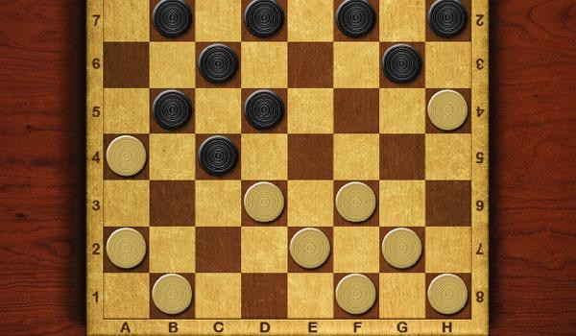
Fig: Checker game board

A checkers learning problem:
  - Task T: playing checkers
  - Performance measure P: percent of games won against opponents
  - Training experience E: playing practice games against itself

A handwriting recognition learning problem:
  - Task T: recognizing and classifying handwritten words within images
  - Performance measure P: percent of words correctly classified
  - Training experience E: a database of handwritten words with given classifications

A robot driving learning problem:
  - Task T: driving on public four-lane highways using vision sensors
  - Performance measure P: average distance travelled before an error (as judged by human overseer)
  - Training experience E: a sequence of images and steering commands recorded while observing a human driver

DESIGNING A LEARNING SYSTEM

The basic design issues and approaches to machine learning are illustrated by designing a program to learn to play checkers, with the goal of entering it in the world checkers tournament
- Choosing the Training Experience
- Choosing the Target Function
- Choosing a Representation for the Target Function
- Choosing a Function Approximation Algorithm
  - Estimating training values
  - Adjusting the weights
- The Final Design

Choosing the Training Experience

  - The first design choice is to choose the type of training experience from which the system will learn.
  - The type of training experience available can have a significant impact on success or failure of the learner.

There are three attributes which impact on success or failure of the learner

- Whether the training experience provides direct or indirect feedback regarding the choices made by the performance system.

For example, in checkers game:
In learning to play checkers, the system might learn from direct training examples
consisting of individual checkers board states and the correct move for each.

Indirect training examples consisting of the move sequences and final outcomes of various games played. The information about the correctness of specific moves early in the game must be inferred indirectly from the fact that the game was eventually won or lost.

Here the learner faces an additional problem of credit assignment, or determining the degree to which each move in the sequence deserves credit or blame for the final outcome. Credit assignment can be a particularly difficult problem because the game can be lost even when early moves are optimal, if these are followed later by poor moves.
Hence, learning from direct training feedback is typically easier than learning from indirect feedback.

- The degree to which the learner controls the sequence of training examples

For example, in checkers game:
The learner might depend on the teacher to select informative board states and to provide the correct move for each.

Alternatively, the learner might itself propose board states that it finds particularly confusing and ask the teacher for the correct move.

The learner may have complete control over both the board states and (indirect) training classifications, as it does when it learns by playing against itself with no teacher present.

- How well it represents the distribution of examples over which the final system performance P must be measured

For example, in checkers game:
In checkers learning scenario, the performance metric P is the percent of games the system wins in the world tournament.

If its training experience E consists only of games played against itself, there is a danger that this training experience might not be fully representative of the distribution of situations over which it will later be tested.
It is necessary to learn from a distribution of examples that is different from those on which the final system will be evaluated.

Choosing the Target Function

The next design choice is to determine exactly what type of knowledge will be learned and how this will be used by the performance program.

Let’s consider a checkers-playing program that can generate the legal moves from any board state.
The program needs only to learn how to choose the best move from among these legal moves. We must learn to choose among the legal moves, the most obvious choice for the type of information to be learned is a program, or function, that chooses the best move for any given board state.

  - Let ChooseMove be the target function and the notation are

ChooseMove : B→ M
which indicate that this function accepts as input any board from the set of legal board states B and produces as output some move from the set of legal moves M.

ChooseMove is a choice for the target function in checkers example, but this function will turn out to be very difficult to learn given the kind of indirect training experience available to our system

  - An alternative target function is an evaluation function that assigns a numerical score
to any given board state
Let the target function V and the notation

V : B → R

which denote that V maps any legal board state from the set B to some real value. Intend for this target function V to assign higher scores to better board states. If the system can successfully learn such a target function V, then it can easily use it to select the best move from any current board position.

Let us define the target value V(b) for an arbitrary board state b in B, as follows:
- If b is a final board state that is won, then V(b) = 100
- If b is a final board state that is lost, then V(b) = -100
- If b is a final board state that is drawn, then V(b) = 0
- If b is a not a final state in the game, then V(b) = V(b' ),

Where b' is the best final board state that can be achieved starting from b and playing optimally until the end of the game

Choosing a Representation for the Target Function

Let’s choose a simple representation - for any given board state, the function c will be calculated as a linear combination of the following board features:

- xl: the number of black pieces on the board
- x2: the number of red pieces on the board
- x3: the number of black kings on the board
- x4: the number of red kings on the board
- x5: the number of black pieces threatened by red (i.e., which can be captured on red's next turn)
- x6: the number of red pieces threatened by black

Thus, learning program will represent as a linear function of the form

Where,
- w0 through w6 are numerical coefficients, or weights, to be chosen by the learning algorithm.
- Learned values for the weights w1 through w6 will determine the relative importance of the various board features in determining the value of the board
- The weight w0 will provide an additive constant to the board value

Choosing a Function Approximation Algorithm

In order to learn the target function f we require a set of training examples, each describing a specific board state b and the training value Vtrain(b) for b.

Each training example is an ordered pair of the form (b, Vtrain(b)).

For instance, the following training example describes a board state b in which black has won the game (note x2 = 0 indicates that red has no remaining pieces) and for which the target function value Vtrain(b) is therefore +100.

((x1=3, x2=0, x3=1, x4=0, x5=0, x6=0), +100)

Function Approximation Procedure

    - Derive training examples from the indirect training experience available to the learner
    - Adjusts the weights wi to best fit these training examples

- Estimating training values

A simple approach for estimating training values for intermediate board states is to
assign the training value of Vtrain(b) for any intermediate board state b to be V̂ (Successor(b))

Where ,
  - V̂ is the learner's current approximation to V
  - Successor(b) denotes the next board state following b for which it is again the program's turn to move

Rule for estimating training values

Vtrain(b) ← V̂ (Successor(b))

- Adjusting the weights
Specify the learning algorithm for choosing the weights wi to best fit the set of training examples {(b, Vtrain(b))}
A first step is to define what we mean by the best fit to the training data.
One common approach is to define the best hypothesis, or set of weights, as that which minimizes the squared error E between the training values and the values predicted by the hypothesis.
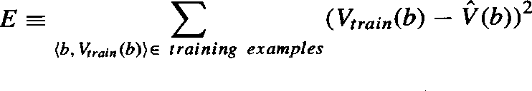
Several algorithms are known for finding weights of a linear function that minimize E. One such algorithm is called the least mean squares, or LMS training rule. For each observed training example, it adjusts the weights a small amount in the direction that reduces the error on this training example

LMS weight update rule: - For each training example (b, Vtrain(b)) Use the current weights to calculate V̂ (b)
For each weight wi, update it as

wi ← wi + ƞ (Vtrain (b) - V̂ (b)) xi

Here ƞ is a small constant (e.g., 0.1) that moderates the size of the weight update. Working of weight update rule
- When the error (Vtrain(b)- V̂ (b)) is zero, no weights are changed.
- When (Vtrain(b) - V̂ (b)) is positive (i.e., when V̂ (b) is too low), then each weight is increased in proportion to the value of its corresponding feature. This will raise the value of V̂ (b), reducing the error.
- If the value of some feature xi is zero, then its weight is not altered regardless of the error, so that the only weights updated are those whose features actually occur on the training example board.

The Final Design
The final design of checkers learning system can be described by four distinct program modules that represent the central components in many learning systems

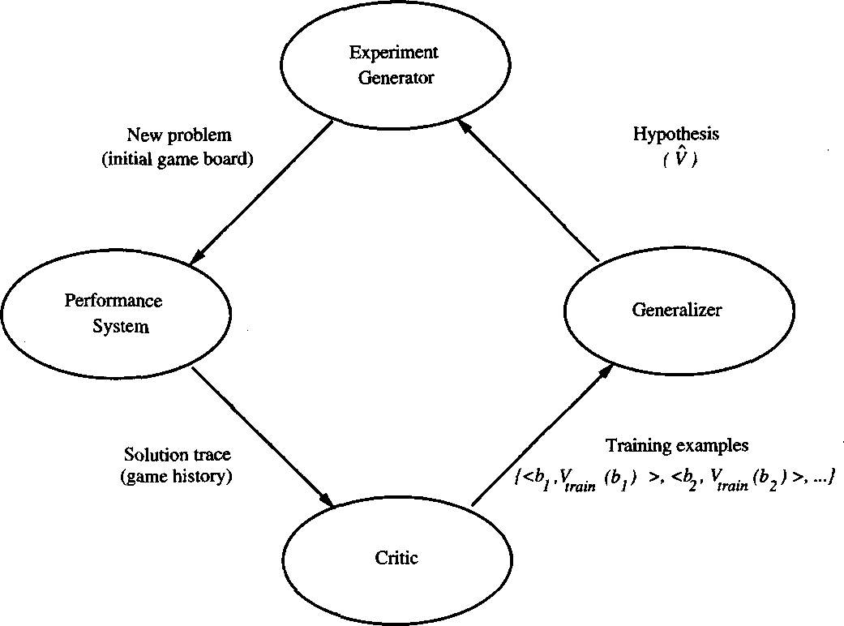

    - The Performance System is the module that must solve the given performance task by using the learned target function(s). It takes an instance of a new problem (new game) as input and produces a trace of its solution (game history) as output.

    - The Critic takes as input the history or trace of the game and produces as output a set of training examples of the target function

    - The Generalizer takes as input the training examples and produces an output hypothesis that is its estimate of the target function. It generalizes from the specific training examples, hypothesizing a general function that covers these examples and other cases beyond the training examples.

    - The Experiment Generator takes as input the current hypothesis and outputs a new problem (i.e., initial board state) for the Performance System to explore. Its role is to pick new practice problems that will maximize the learning rate of the overall system.

The sequence of design choices made for the checkers program is summarized in below figure

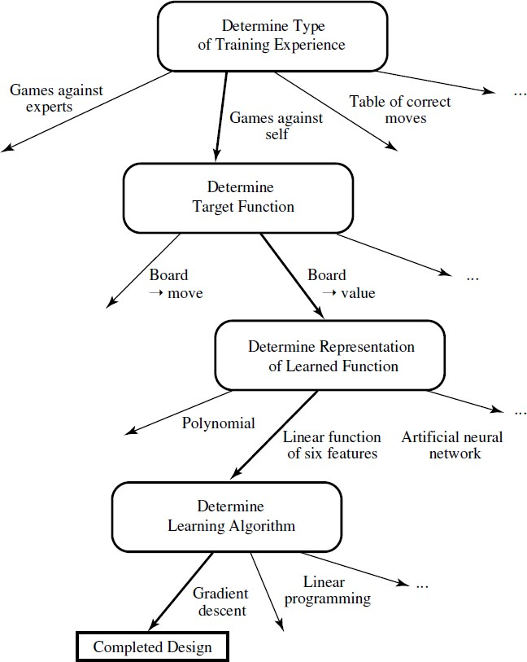

PERSPECTIVES AND ISSUES IN MACHINE LEARNING

Issues in Machine Learning
The field of machine learning, and much of this book, is concerned with answering questions such as the following
- What algorithms exist for learning general target functions from specific training examples? In what settings will particular algorithms converge to the desired function, given sufficient training data? Which algorithms perform best for which types of problems and representations?
- How much training data is sufficient? What general bounds can be found to relate the confidence in learned hypotheses to the amount of training experience and the character of the learner's hypothesis space?

- When and how can prior knowledge held by the learner guide the process of generalizing from examples? Can prior knowledge be helpful even when it is only approximately correct?
- What is the best strategy for choosing a useful next training experience, and how does the choice of this strategy alter the complexity of the learning problem?
- What is the best way to reduce the learning task to one or more function approximation problems? Put another way, what specific functions should the system attempt to learn? Can this process itself be automated?
- How can the learner automatically alter its representation to improve its ability to represent and learn the target function?

CONCEPT LEARNING

- Learning involves acquiring general concepts from specific training examples. Example: People continually learn general concepts or categories such as "bird," "car," "situations in which I should study more in order to pass the exam," etc.
- Each such concept can be viewed as describing some subset of objects or events defined over a larger set
- Alternatively, each concept can be thought of as a Boolean-valued function defined over this larger set. (Example: A function defined over all animals, whose value is true for birds and false for other animals).

Definition: Concept learning - Inferring a Boolean-valued function from training examples of its input and output

A CONCEPT LEARNING TASK

Consider the example task of learning the target concept "Days on which Aldo enjoys his favorite water sport”

Example | Sky | AirTemp | Humidity | Wind | Water | Forecast | EnjoySport
1 | Sunny | Warm | Normal | Strong | Warm | Same | Yes
2 | Sunny | Warm | High | Strong | Warm | Same | Yes
3 | Rainy | Cold | High | Strong | Warm | Change | No
4 | Sunny | Warm | High | Strong | Cool | Change | Yes
Table: Positive and negative training examples for the target concept EnjoySport.

The task is to learn to predict the value of EnjoySport for an arbitrary day, based on the values of its other attributes?

What hypothesis representation is provided to the learner?

  - Let’s consider a simple representation in which each hypothesis consists of a conjunction of constraints on the instance attributes.
  - Let each hypothesis be a vector of six constraints, specifying the values of the six attributes Sky, AirTemp, Humidity, Wind, Water, and Forecast.

For each attribute, the hypothesis will either
  - Indicate by a "?' that any value is acceptable for this attribute,
  - Specify a single required value (e.g., Warm) for the attribute, or
  - Indicate by a "Φ" that no value is acceptable

If some instance x satisfies all the constraints of hypothesis h, then h classifies x as a positive example (h(x) = 1).

The hypothesis that PERSON enjoys his favorite sport only on cold days with high humidity is represented by the expression
(?, Cold, High, ?, ?, ?)

The most general hypothesis-that every day is a positive example-is represented by
(?, ?, ?, ?, ?, ?)

The most specific possible hypothesis-that no day is a positive example-is represented by
(Φ, Φ, Φ, Φ, Φ, Φ)

Notation

- The set of items over which the concept is defined is called the set of instances, which is denoted by X.

Example: X is the set of all possible days, each represented by the attributes: Sky, AirTemp, Humidity, Wind, Water, and Forecast

- The concept or function to be learned is called the target concept, which is denoted by c. c can be any Boolean valued function defined over the instances X

c: X→ {O, 1}

Example: The target concept corresponds to the value of the attribute EnjoySport
(i.e., c(x) = 1 if EnjoySport = Yes, and c(x) = 0 if EnjoySport = No).

- Instances for which c(x) = 1 are called positive examples, or members of the target concept.
- Instances for which c(x) = 0 are called negative examples, or non-members of the target concept.
- The ordered pair (x, c(x)) to describe the training example consisting of the instance x and its target concept value c(x).
- D to denote the set of available training examples

- The symbol H to denote the set of all possible hypotheses that the learner may consider regarding the identity of the target concept. Each hypothesis h in H represents a Boolean- valued function defined over X
h: X→{O, 1}

The goal of the learner is to find a hypothesis h such that h(x) = c(x) for all x in X.

- Given:
  - Instances X: Possible days, each described by the attributes
    - Sky (with possible values Sunny, Cloudy, and Rainy),
    - AirTemp (with values Warm and Cold),
    - Humidity (with values Normal and High),
    - Wind (with values Strong and Weak),
    - Water (with values Warm and Cool),
    - Forecast (with values Same and Change).

  - Hypotheses H: Each hypothesis is described by a conjunction of constraints on the attributes Sky, AirTemp, Humidity, Wind, Water, and Forecast. The constraints may be "?" (any value is acceptable), “Φ” (no value is acceptable), or a specific value.

  - Target concept c: EnjoySport : X → {0, l}
  - Training examples D: Positive and negative examples of the target function

- Determine:
  - A hypothesis h in H such that h(x) = c(x) for all x in X.

Table: The EnjoySport concept learning task.

The inductive learning hypothesis

Any hypothesis found to approximate the target function well over a sufficiently large set of training examples will also approximate the target function well over other unobserved examples.

CONCEPT LEARNING AS SEARCH

  - Concept learning can be viewed as the task of searching through a large space of hypotheses implicitly defined by the hypothesis representation.
  - The goal of this search is to find the hypothesis that best fits the training examples.

Example:
Consider the instances X and hypotheses H in the EnjoySport learning task. The attribute Sky has three possible values, and AirTemp, Humidity, Wind, Water, Forecast each have two possible values, the instance space X contains exactly
3.2.2.2.2.2 = 96 distinct instances
5.4.4.4.4.4 = 5120 syntactically distinct hypotheses within H.

Every hypothesis containing one or more "Φ" symbols represents the empty set of instances; that is, it classifies every instance as negative.
1 + (4.3.3.3.3.3) = 973. Semantically distinct hypotheses

General-to-Specific Ordering of Hypotheses

Consider the two hypotheses
h1 = (Sunny, ?, ?, Strong, ?, ?)
h2 = (Sunny, ?, ?, ?, ?, ?)

  - Consider the sets of instances that are classified positive by hl and by h2.
  - h2 imposes fewer constraints on the instance, it classifies more instances as positive. So, any instance classified positive by hl will also be classified positive by h2. Therefore, h2 is more general than hl.

Given hypotheses hj and hk, hj is more-general-than or- equal do hk if and only if any instance that satisfies hk also satisfies hi

Definition: Let hj and hk be Boolean-valued functions defined over X. Then hj is more general- than-or-equal-to hk (written hj ≥ hk) if and only if

(∀ x∈X ) [(h_{k} (x) = 1) → (h_{j} (x) = 1)]

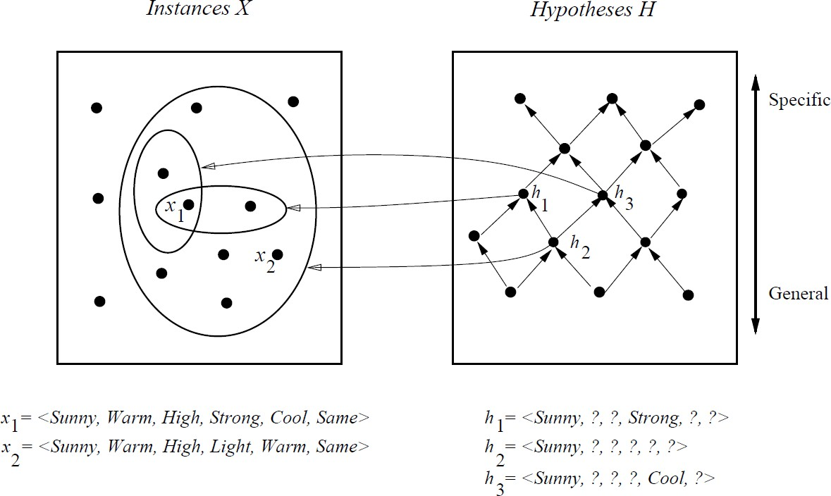

  - In the figure, the box on the left represents the set X of all instances, the box on the right the set H of all hypotheses.
  - Each hypothesis corresponds to some subset of X-the subset of instances that it classifies positive.
  - The arrows connecting hypotheses represent the more - general -than relation, with the arrow pointing toward the less general hypothesis.
  - Note the subset of instances characterized by h2 subsumes the subset characterized by hl , hence h2 is more - general– than h1

FIND-S: FINDING A MAXIMALLY SPECIFIC HYPOTHESIS

FIND-S Algorithm

Initialize h to the most specific hypothesis in H
- For each positive training instance x

For each attribute constraint ai in h
If the constraint ai is satisfied by x

Then do nothing
Else replace ai in h by the next more general constraint that is satisfied by x

Output hypothesis h

To illustrate this algorithm, assume the learner is given the sequence of training examples from the EnjoySport task

Example | Sky | AirTemp | Humidity | Wind | Water | Forecast | EnjoySport
1 | Sunny | Warm | Normal | Strong | Warm | Same | Yes
2 | Sunny | Warm | High | Strong | Warm | Same | Yes
3 | Rainy | Cold | High | Strong | Warm | Change | No
4 | Sunny | Warm | High | Strong | Cool | Change | Yes

  - The first step of FIND-S is to initialize h to the most specific hypothesis in H
h - (Ø, Ø, Ø, Ø, Ø, Ø)

  - Consider the first training example
x1 = <Sunny Warm Normal Strong Warm Same>, +

Observing the first training example, it is clear that hypothesis h is too specific. None of the "Ø" constraints in h are satisfied by this example, so each is replaced by the next more general constraint that fits the example
h1 = <Sunny Warm Normal Strong Warm Same>

  - Consider the second training example
x2 = <Sunny, Warm, High, Strong, Warm, Same>, +

The second training example forces the algorithm to further generalize h, this time substituting a "?" in place of any attribute value in h that is not satisfied by the new example
h2 = <Sunny Warm ? Strong Warm Same>

  - Consider the third training example
x3 = <Rainy, Cold, High, Strong, Warm, Change>, -

Upon encountering the third training the algorithm makes no change to h. The FIND-S algorithm simply ignores every negative example.
h3 = < Sunny Warm ? Strong Warm Same>

  - Consider the fourth training example
x4 = <Sunny Warm High Strong Cool Change>, +

The fourth example leads to a further generalization of h
h4 = < Sunny Warm ? Strong ? ? >

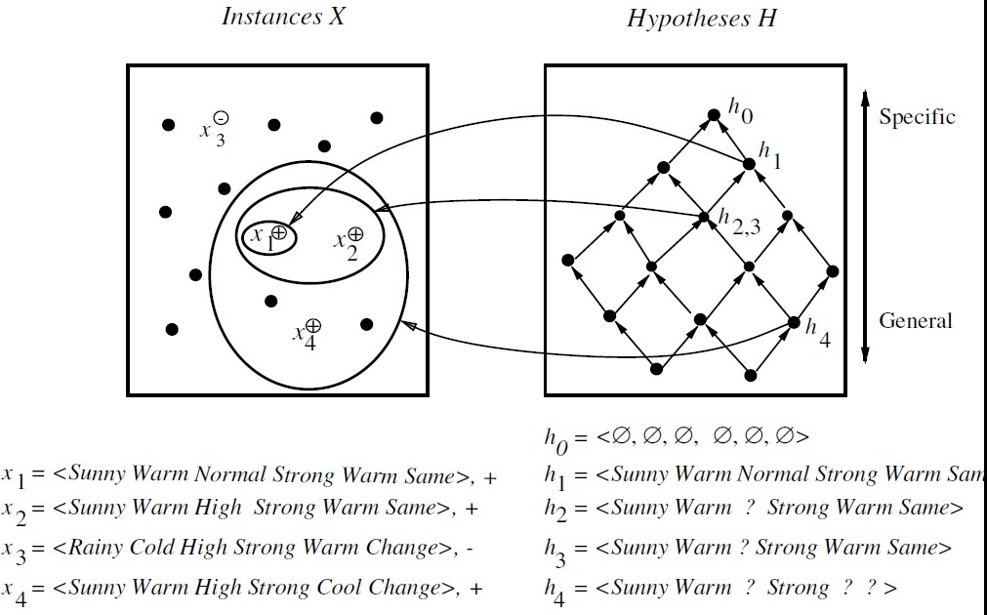

The key property of the FIND-S algorithm
  - FIND-S is guaranteed to output the most specific hypothesis within H that is consistent with the positive training examples
  - FIND-S algorithm’s final hypothesis will also be consistent with the negative examples provided the correct target concept is contained in H, and provided the training examples are correct.

Unanswered by FIND-S

- Has the learner converged to the correct target concept?
- Why prefer the most specific hypothesis?
- Are the training examples consistent?
- What if there are several maximally specific consistent hypotheses?

VERSION SPACES AND THE CANDIDATE-ELIMINATION ALGORITHM

The key idea in the CANDIDATE-ELIMINATION algorithm is to output a description of the set of all hypotheses consistent with the training examples

Representation

Definition: consistent- A hypothesis h is consistent with a set of training examples D if and
only if h(x) = c(x) for each example (x, c(x)) in D.
Consistent (h, D) ≡ (∀ ⟨x, c(x)⟩ ∈ D) h(x) = c(x)) Note difference between definitions of consistent and satisfies
  - An example x is said to satisfy hypothesis h when h(x) = 1, regardless of whether x is a positive or negative example of the target concept.
  - An example x is said to consistent with hypothesis h iff h(x) = c(x)

Definition: version space- The version space, denoted V S with respect to hypothesis space
H, D
H and training examples D, is the subset of hypotheses from H consistent with the training examples in D
V S ≡{h ∈ H | Consistent (h, D)}
H, D

The LIST-THEN-ELIMINATION algorithm

The LIST-THEN-ELIMINATE algorithm first initializes the version space to contain all hypotheses in H and then eliminates any hypothesis found inconsistent with any training example.

- VersionSpace c a list containing every hypothesis in H
- For each training example, (x, c(x))
remove from VersionSpace any hypothesis h for which h(x) ≠ c(x)
- Output the list of hypotheses in VersionSpace

The LIST-THEN-ELIMINATE Algorithm

  - List-Then-Eliminate works in principle, so long as version space is finite.
  - However, since it requires exhaustive enumeration of all hypotheses in practice it is not feasible.

A More Compact Representation for Version Spaces

The version space is represented by its most general and least general members. These members form general and specific boundary sets that delimit the version space within the partially ordered hypothesis space.

Definition: The general boundary G, with respect to hypothesis space H and training data D,
is the set of maximally general members of H consistent with D

G ≡{g ∈ H | Consistent (g, D)∧(¬∃g' ∈ H)[(g' > g) ∧ Consistent(g', D)]}
g

Definition: The specific boundary S, with respect to hypothesis space H and training data D,
is the set of minimally general (i.e., maximally specific) members of H consistent with D.

S ≡{s ∈ H | Consistent (s, D)∧(¬∃s' ∈ H)[(s > s') ∧ Consistent(s', D)]}
g

Theorem: Version Space representation theorem
Theorem: Let X be an arbitrary set of instances and Let H be a set of Boolean-valued hypotheses defined over X. Let c: X →{O, 1} be an arbitrary target concept defined over X, and let D be an arbitrary set of training examples {(x, c(x))). For all X, H, c, and D such that S and G are well defined,
VS ={ h ∈ H | (∃s ∈ S ) (∃g ∈ G ) ( g ≥ h ≥ s )}
H,D g g
To Prove:
- Every h satisfying the right hand side of the above expression is in VS
H, D
- Every member of VS satisfies the right-hand side of the expression
H, D

Sketch of proof:
  - let g, h, s be arbitrary members of G, H, S respectively with g ≥g h ≥g s
- By the definition of S, s must be satisfied by all positive examples in D. Because h ≥g s,
h must also be satisfied by all positive examples in D.
- By the definition of G, g cannot be satisfied by any negative example in D, and because g ≥g h h cannot be satisfied by any negative example in D. Because h is satisfied by all positive examples in D and by no negative examples in D, h is consistent with D, and therefore h is a member of VSH,D.
  - It can be proven by assuming some h in VSH,D,that does not satisfy the right-hand side of the expression, then showing that this leads to an inconsistency

CANDIDATE-ELIMINATION Learning Algorithm

The CANDIDATE-ELIMINTION algorithm computes the version space containing all hypotheses from H that are consistent with an observed sequence of training examples.

Initialize G to the set of maximally general hypotheses in H Initialize S to the set of maximally specific hypotheses in H For each training example d, do
- If d is a positive example
  - Remove from G any hypothesis inconsistent with d
  - For each hypothesis s in S that is not consistent with d
    - Remove s from S
    - Add to S all minimal generalizations h of s such that
      - h is consistent with d, and some member of G is more general than h
    - Remove from S any hypothesis that is more general than another hypothesis in S

- If d is a negative example
  - Remove from S any hypothesis inconsistent with d
  - For each hypothesis g in G that is not consistent with d
    - Remove g from G
    - Add to G all minimal specializations h of g such that
      - h is consistent with d, and some member of S is more specific than h
    - Remove from G any hypothesis that is less general than another hypothesis in G

CANDIDATE- ELIMINTION algorithm using version spaces

An Illustrative Example

Example | Sky | AirTemp | Humidity | Wind | Water | Forecast | EnjoySport
1 | Sunny | Warm | Normal | Strong | Warm | Same | Yes
2 | Sunny | Warm | High | Strong | Warm | Same | Yes
3 | Rainy | Cold | High | Strong | Warm | Change | No
4 | Sunny | Warm | High | Strong | Cool | Change | Yes

CANDIDATE-ELIMINTION algorithm begins by initializing the version space to the set of all hypotheses in H;

Initializing the G boundary set to contain the most general hypothesis in H
G0 ⟨?, ?, ?, ?, ?, ?⟩

Initializing the S boundary set to contain the most specific (least general) hypothesis
S0 ⟨∅, ∅, ∅, ∅, ∅, ∅⟩

- When the first training example is presented, the CANDIDATE-ELIMINTION algorithm checks the S boundary and finds that it is overly specific and it fails to cover the positive example.
- The boundary is therefore revised by moving it to the least more general hypothesis that covers this new example
- No update of the G boundary is needed in response to this training example because Go correctly covers this example
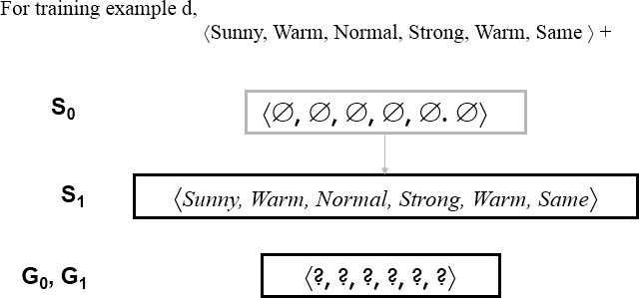

  - When the second training example is observed, it has a similar effect of generalizing S further to S2, leaving G again unchanged i.e., G2 = G1 = G0

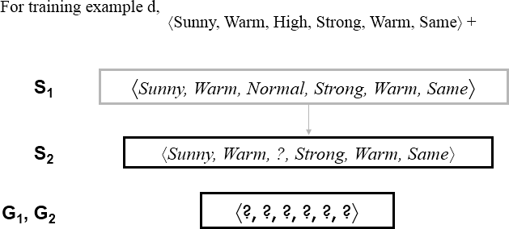

  - Consider the third training example. This negative example reveals that the G boundary of the version space is overly general, that is, the hypothesis in G incorrectly predicts that this new example is a positive example.
  - The hypothesis in the G boundary must therefore be specialized until it correctly classifies this new negative example

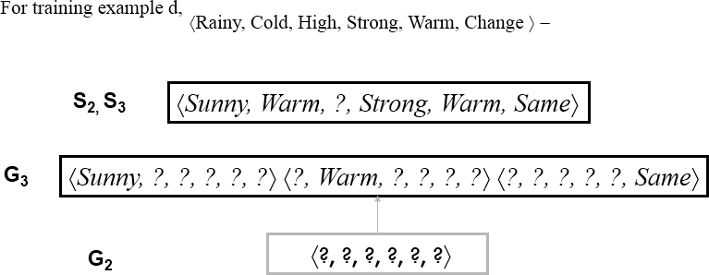

Given that there are six attributes that could be specified to specialize G2, why are there only three new hypotheses in G3?
For example, the hypothesis h = (?, ?, Normal, ?, ?, ?) is a minimal specialization of G2 that correctly labels the new example as a negative example, but it is not included in G3. The reason this hypothesis is excluded is that it is inconsistent with the previously encountered positive examples

  - Consider the fourth training example.

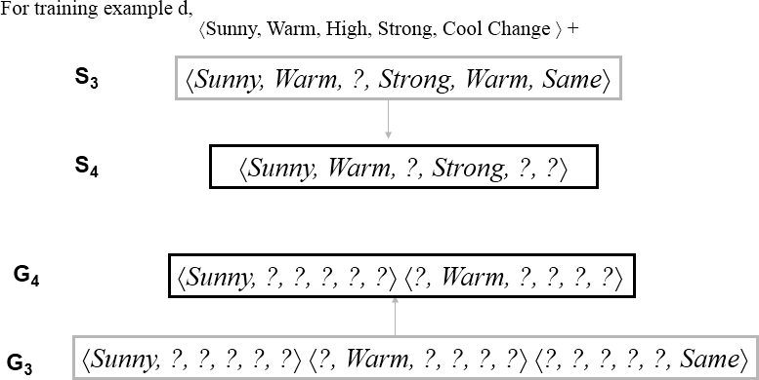

  - This positive example further generalizes the S boundary of the version space. It also results in removing one member of the G boundary, because this member fails to cover the new positive example

After processing these four examples, the boundary sets S4 and G4 delimit the version space of all hypotheses consistent with the set of incrementally observed training examples.

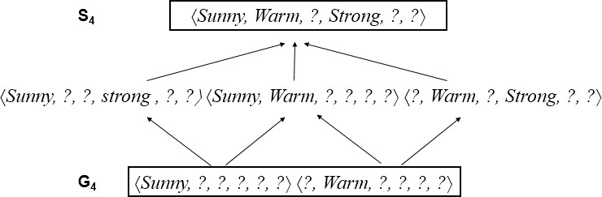

INDUCTIVE BIAS

The fundamental questions for inductive inference

- What if the target concept is not contained in the hypothesis space?
- Can we avoid this difficulty by using a hypothesis space that includes every possible hypothesis?
- How does the size of this hypothesis space influence the ability of the algorithm to generalize to unobserved instances?
- How does the size of the hypothesis space influence the number of training examples that must be observed?

These fundamental questions are examined in the context of the CANDIDATE- ELIMINTION algorithm

A Biased Hypothesis Space

- Suppose the target concept is not contained in the hypothesis space H, then obvious solution is to enrich the hypothesis space to include every possible hypothesis.
  - Consider the EnjoySport example in which the hypothesis space is restricted to include only conjunctions of attribute values. Because of this restriction, the hypothesis space is unable to represent even simple disjunctive target concepts such as
"Sky = Sunny or Sky = Cloudy."
  - The following three training examples of disjunctive hypothesis, the algorithm would find that there are zero hypotheses in the version space

⟨Sunny Warm Normal Strong Cool Change⟩ Y
⟨Cloudy Warm Normal Strong Cool Change⟩ Y
⟨Rainy Warm Normal Strong Cool Change⟩ N

  - If Candidate Elimination algorithm is applied, then it end up with empty Version Space. After first two training example
S= ⟨? Warm Normal Strong Cool Change⟩

  - This new hypothesis is overly general and it incorrectly covers the third negative training example! So H does not include the appropriate c.
  - In this case, a more expressive hypothesis space is required.

An Unbiased Learner

- The solution to the problem of assuring that the target concept is in the hypothesis space H is to provide a hypothesis space capable of representing every teachable concept that is representing every possible subset of the instances X.
- The set of all subsets of a set X is called the power set of X

  - In the EnjoySport learning task the size of the instance space X of days described by the six attributes is 96 instances.
  - Thus, there are 2⁹⁶ distinct target concepts that could be defined over this instance space and learner might be called upon to learn.
  - The conjunctive hypothesis space is able to represent only 973 of these - a biased hypothesis space indeed

  - Let us reformulate the EnjoySport learning task in an unbiased way by defining a new hypothesis space H' that can represent every subset of instances
  - The target concept "Sky = Sunny or Sky = Cloudy" could then be described as

(Sunny, ?, ?, ?, ?, ?) v (Cloudy, ?, ?, ?, ?, ?)

The Futility of Bias-Free Learning

Inductive learning requires some form of prior assumptions, or inductive bias

Definition:
Consider a concept learning algorithm L for the set of instances X.
  - Let c be an arbitrary concept defined over X

  - Let D
c
= {(x , c(x))} be an arbitrary set of training examples of c.

  - Let L (x , D ) denote the classification assigned to the instance x
by L after training on

i c i
the data D .
c
  - The inductive bias of L is any minimal set of assertions B such that for any target concept c and corresponding training examples D
c

    - (∀ ⟨xi ∈ X ) [(B ∧ Dc ∧ xi) ├ L (xi, Dc )]

The below figure explains
  - Modelling inductive systems by equivalent deductive systems.
  - The input-output behavior of the CANDIDATE-ELIMINATION algorithm using a hypothesis space H is identical to that of a deductive theorem prover utilizing the assertion "H contains the target concept." This assertion is therefore called the inductive bias of the CANDIDATE-ELIMINATION algorithm.
  - Characterizing inductive systems by their inductive bias allows modelling them by their equivalent deductive systems. This provides a way to compare inductive systems according to their policies for generalizing beyond the observed training data.

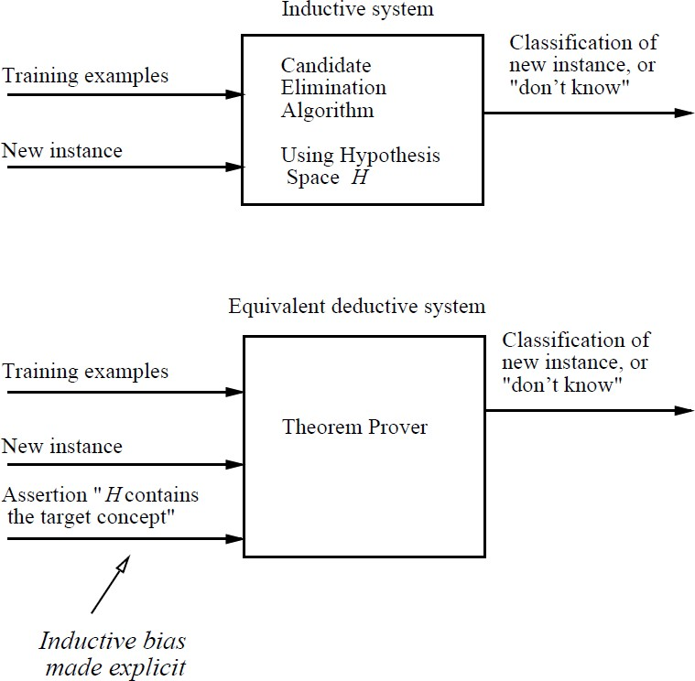

DECISION TREE LEARNING

Decision tree learning is a method for approximating discrete-valued target functions, in which the learned function is represented by a decision tree.

DECISION TREE REPRESENTATION

- Decision trees classify instances by sorting them down the tree from the root to some leaf node, which provides the classification of the instance.
- Each node in the tree specifies a test of some attribute of the instance, and each branch descending from that node corresponds to one of the possible values for this attribute.
- An instance is classified by starting at the root node of the tree, testing the attribute specified by this node, then moving down the tree branch corresponding to the value of the attribute in the given example. This process is then repeated for the subtree rooted at the new node.

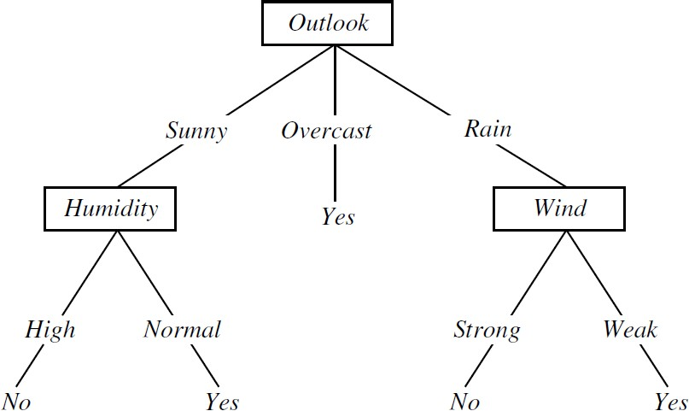

FIGURE: A decision tree for the concept PlayTennis. An example is classified by sorting it through the tree to the appropriate leaf node, then returning the classification associated with this leaf

- Decision trees represent a disjunction of conjunctions of constraints on the attribute values of instances.
- Each path from the tree root to a leaf corresponds to a conjunction of attribute tests, and the tree itself to a disjunction of these conjunctions

For example, the decision tree shown in above figure corresponds to the expression (Outlook = Sunny 𝖠 Humidity = Normal)
∨ (Outlook = Overcast)
∨ (Outlook = Rain 𝖠 Wind = Weak)

APPROPRIATE PROBLEMS FOR DECISION TREE LEARNING

Decision tree learning is generally best suited to problems with the following characteristics:

- Instances are represented by attribute-value pairs – Instances are described by a fixed set of attributes and their values

- The target function has discrete output values – The decision tree assigns a Boolean classification (e.g., yes or no) to each example. Decision tree methods easily extend to learning functions with more than two possible output values.

- Disjunctive descriptions may be required

- The training data may contain errors – Decision tree learning methods are robust to errors, both errors in classifications of the training examples and errors in the attribute values that describe these examples.

- The training data may contain missing attribute values – Decision tree methods can be used even when some training examples have unknown values

THE BASIC DECISION TREE LEARNING ALGORITHM

The basic algorithm is ID3 which learns decision trees by constructing them top-down

ID3(Examples, Target_attribute, Attributes)

Examples are the training examples. Target_attribute is the attribute whose value is to be predicted by the tree. Attributes is a list of other attributes that may be tested by the learned decision tree. Returns a decision tree that correctly classifies the given Examples.

- Create a Root node for the tree
- If all Examples are positive, Return the single-node tree Root, with label = +
- If all Examples are negative, Return the single-node tree Root, with label = -
- If Attributes is empty, Return the single-node tree Root, with label = most common value of Target_attribute in Examples

- Otherwise Begin
  - A ← the attribute from Attributes that best* classifies Examples
  - The decision attribute for Root ← A
  - For each possible value, vi, of A,
    - Add a new tree branch below Root, corresponding to the test A = vi
    - Let Examples vi, be the subset of Examples that have value vi for A
    - If Examples vi , is empty
      - Then below this new branch add a leaf node with label = most common value of Target_attribute in Examples
      - Else below this new branch add the subtree ID3(Examples vi, Targe_tattribute, Attributes – {A}))
- End
- Return Root

- The best attribute is the one with highest information gain

TABLE: Summary of the ID3 algorithm specialized to learning Boolean-valued functions. ID3 is a greedy algorithm that grows the tree top-down, at each node selecting the attribute that best classifies the local training examples. This process continues until the tree perfectly classifies the training examples, or until all attributes have been used

Which Attribute Is the Best Classifier?

  - The central choice in the ID3 algorithm is selecting which attribute to test at each node in the tree.
  - A statistical property called information gain that measures how well a given attribute separates the training examples according to their target classification.
  - ID3 uses information gain measure to select among the candidate attributes at each step while growing the tree.

ENTROPY MEASURES HOMOGENEITY OF EXAMPLES

To define information gain, we begin by defining a measure called entropy. Entropy measures the impurity of a collection of examples.

Given a collection S, containing positive and negative examples of some target concept, the entropy of S relative to this Boolean classification is

Where,

p+ is the proportion of positive examples in S
- is the proportion of negative examples in S.

Example:
Suppose S is a collection of 14 examples of some boolean concept, including 9 positive and 5 negative examples. Then the entropy of S relative to this boolean classification is

  - The entropy is 0 if all members of S belong to the same class
  - The entropy is 1 when the collection contains an equal number of positive and negative examples
  - If the collection contains unequal numbers of positive and negative examples, the entropy is between 0 and 1

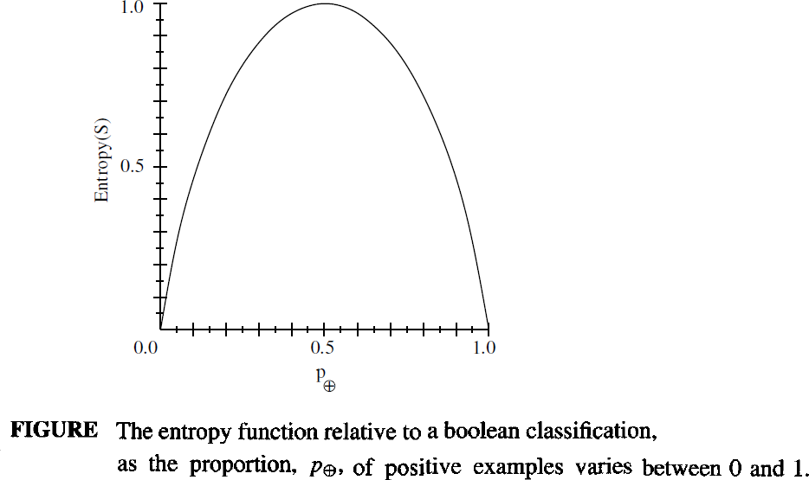

INFORMATION GAIN MEASURES THE EXPECTED REDUCTION IN ENTROPY

  - Information gain, is the expected reduction in entropy caused by partitioning the examples according to this attribute.
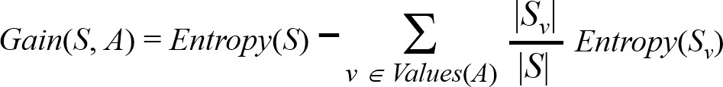
  - The information gain, Gain(S, A) of an attribute A, relative to a collection of examples S, is defined as

Example: Information gain

Let, Values(Wind) = {Weak, Strong} S = [9+, 5−]
S = [6+, 2−]
Weak
S = [3+, 3−]
Strong

Information gain of attribute Wind:
Gain(S, Wind) = Entropy(S) − 8/14 Entropy (SWeak) − 6/14 Entropy (SStrong)
= 0.94 – (8/14)* 0.811 – (6/14) *1.00
= 0.048

An Illustrative Example

  - To illustrate the operation of ID3, consider the learning task represented by the training examples of below table.
  - Here the target attribute PlayTennis, which can have values yes or no for different days.
  - Consider the first step through the algorithm, in which the topmost node of the decision tree is created.

Day | Outlook | Temperature | Humidity | Wind | PlayTennis
D1 | Sunny | Hot | High | Weak | No
D2 | Sunny | Hot | High | Strong | No
D3 | Overcast | Hot | High | Weak | Yes
D4 | Rain | Mild | High | Weak | Yes
D5 | Rain | Cool | Normal | Weak | Yes
D6 | Rain | Cool | Normal | Strong | No
D7 | Overcast | Cool | Normal | Strong | Yes
D8 | Sunny | Mild | High | Weak | No
D9 | Sunny | Cool | Normal | Weak | Yes
D10 | Rain | Mild | Normal | Weak | Yes
D11 | Sunny | Mild | Normal | Strong | Yes
D12 | Overcast | Mild | High | Strong | Yes
D13 | Overcast | Hot | Normal | Weak | Yes
D14 | Rain | Mild | High | Strong | No

  - ID3 determines the information gain for each candidate attribute (i.e., Outlook, Temperature, Humidity, and Wind), then selects the one with highest information gain.

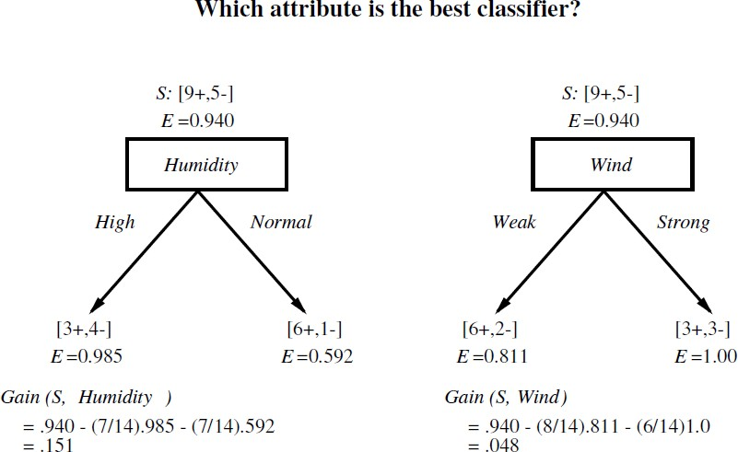

  - The information gain values for all four attributes are
Gain(S, Outlook) = 0.246
Gain(S, Humidity) = 0.151
Gain(S, Wind) = 0.048 Gain(S, Temperature) = 0.029
  - According to the information gain measure, the Outlook attribute provides the best prediction of the target attribute, PlayTennis, over the training examples. Therefore, Outlook is selected as the decision attribute for the root node, and branches are created below the root for each of its possible values i.e., Sunny, Overcast, and Rain.

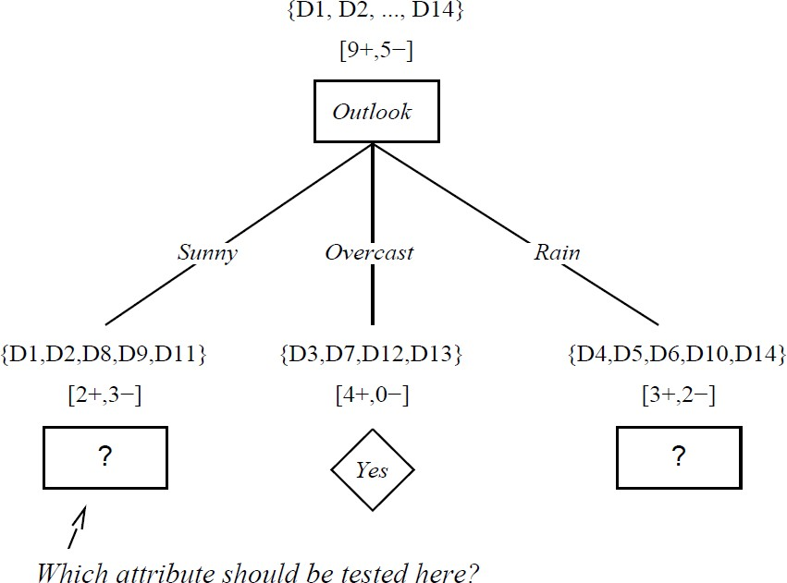

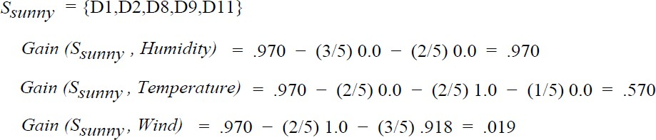

SRain = { D4, D5, D6, D10, D14}

Gain (SRain , Humidity) = 0.970 – (2/5)1.0 – (3/5)0.917 = 0.019
Gain (SRain , Temperature) =0.970 – (0/5)0.0 – (3/5)0.918 – (2/5)1.0 = 0.019
Gain (SRain , Wind) =0.970 – (3/5)0.0 – (2/5)0.0 = 0.970

HYPOTHESIS SPACE SEARCH IN DECISION TREE LEARNING

  - ID3 can be characterized as searching a space of hypotheses for one that fits the training examples.
  - The hypothesis space searched by ID3 is the set of possible decision trees.
  - ID3 performs a simple-to complex, hill-climbing search through this hypothesis space, beginning with the empty tree, then considering progressively more elaborate hypotheses in search of a decision tree that correctly classifies the training data
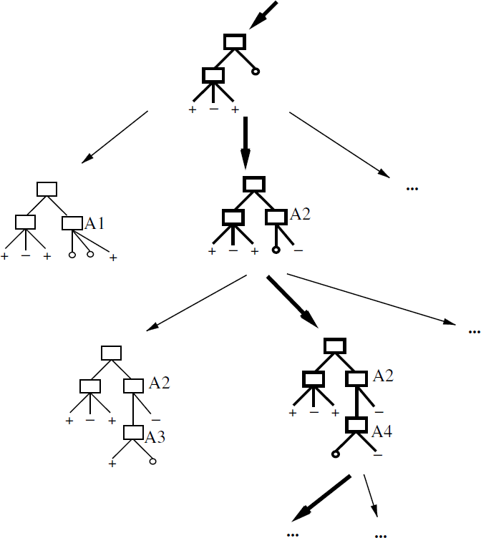

Figure: Hypothesis space search by ID3. ID3 searches through the space of possible decision trees from simplest to increasingly complex, guided by the information gain heuristic.

By viewing ID3 in terms of its search space and search strategy, there are some insight into its capabilities and limitations

- ID3's hypothesis space of all decision trees is a complete space of finite discrete-valued functions, relative to the available attributes. Because every finite discrete-valued function can be represented by some decision tree
ID3 avoids one of the major risks of methods that search incomplete hypothesis spaces: that the hypothesis space might not contain the target function.

- ID3 maintains only a single current hypothesis as it searches through the space of decision trees.
For example, with the earlier version space candidate elimination method, which maintains the set of all hypotheses consistent with the available training examples.

By determining only a single hypothesis, ID3 loses the capabilities that follow from explicitly representing all consistent hypotheses.
For example, it does not have the ability to determine how many alternative decision trees are consistent with the available training data, or to pose new instance queries that optimally resolve among these competing hypotheses

- ID3 in its pure form performs no backtracking in its search. Once it selects an attribute to test at a particular level in the tree, it never backtracks to reconsider this choice.
In the case of ID3, a locally optimal solution corresponds to the decision tree it selects along the single search path it explores. However, this locally optimal solution may be less desirable than trees that would have been encountered along a different branch of the search.

- ID3 uses all training examples at each step in the search to make statistically based decisions regarding how to refine its current hypothesis.
One advantage of using statistical properties of all the examples is that the resulting search is much less sensitive to errors in individual training examples.
ID3 can be easily extended to handle noisy training data by modifying its termination criterion to accept hypotheses that imperfectly fit the training data.

